**FLAT**

**ASSIGNMENT**

**Name: M. Yashvanth kumar**

**ROOL NO: 21071A6738**

**SECTION: CS-DS**

Part-A

**a)Define string & differentiate between prefix and suffix of a string with example?**

String :

A string is a sequence of characters, typically used to represent text or a collection of characters in computer programming.

Prefix:

A prefix of a string is a substring that appears at the beginning of the string.

Suffix:

A suffix of a string is a substring that appears at the end of the string.

Example:

Consider the string "Hello new World!".

Prefix : "Hello"

Suffix: " World!"

**b)Design regular expression for the language of all the strings containing any number of a’s and b’s**

The regular expression will be:

r.e. = (a + b)*

This will give the set as L = {ε, a, aa, b, bb, ab, ba, aba, bab, .....}, any combination of a and b.

The (a + b)* shows any combination with a and b even a null string.

**c)Construct cfg for the language having any number of a’s over the set ∑ = {a}**

All combinations of a's means a may be zero, single, double and so on. If a is appearing zero times,

that means a null string. That is we expect the set of {ε, a, aa, aaa, ....}. So we give a regular

expression for this as:

R = a*

Part-B

**1) derive the string “aaabbabbba” using right and lest sentential forms for the given grammar?**

**S->aA|bB ,A->a|aS|bAA ,B->b|bS|aBB**

To derive the string "aaabbabbba" using right and left sentential forms for the given grammar, we'll start with the start symbol 'S' and apply the production rules to expand it step by step.

**Right Sentential Form:**

Starting with the right sentential form, we'll replace the non-terminal symbols from right to left until we reach the desired string.

S (Start with the start symbol)

aA (Applied production rule S -> aA)

aaS (Applied production rule A -> aS)

aaaS (Applied production rule A -> aS)

aaabbB (Applied production rule S -> bB)

aaabbabS (Applied production rule B -> bS)

aaabbabbBa (Applied production rule S -> aB)

aaabbabbba (Applied production rule B -> b)

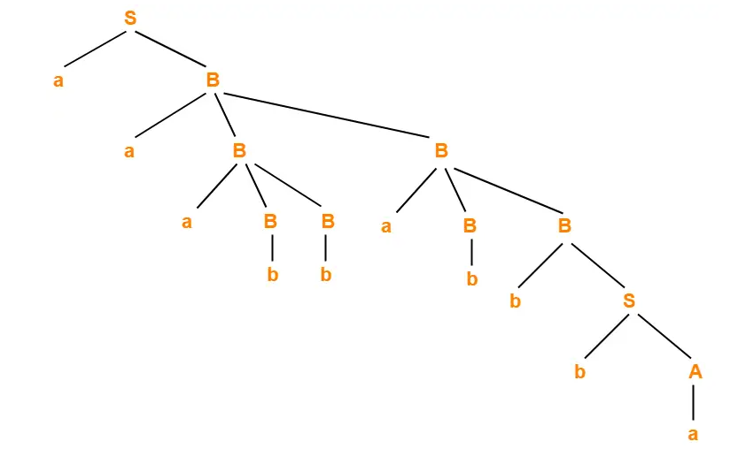

**Left Sentential Form:**

Now let's derive the string "aaabbabbba" using the left sentential form, where we replace non-terminal symbols from left to right.

S (Start with the start symbol)

aA (Applied production rule S -> aA)

aaS (Applied production rule A -> aS)

aaaS (Applied production rule A -> aS)

aaabB (Applied production rule S -> bB)

aaabbSb (Applied production rule B -> bS)

aaabbabSb (Applied production rule B -> bS)

aaabbabbBa (Applied production rule S -> aB)

aaabbabbba (Applied production rule B -> b)

The left sentential form for the string "aaabbabbba" is: S -> aA -> aaS -> aaaS -> aaabB -> aaabbSb -> aaabbabSb -> aaabbabbBa -> aaabbabbba

Both the right and left sentential forms lead to the string "aaabbabbba" by applying the production rules of the given grammar.

**2)Apply pumping lemma to show that the language L={a^p |p is a prime } is not a regular?**

To apply the pumping lemma to show that the language L = {a^p | p is a prime} is not regular, we need to assume that L is regular and then derive a contradiction.

The pumping lemma states that for any regular language L, there exists a constant n (the "pumping length") such that any string s in L with a length of n or more can be divided into three parts: s = xyz, where the following conditions hold:

The length of xy is at most n.

The length of y is greater than 0.

For all non-negative integers i, the string xy^iz is also in L.

Now let's assume that L = {a^p | p is a prime} is a regular language. We will proceed to derive a contradiction using the pumping lemma.

Assume L is regular, so it satisfies the pumping lemma.

Let n be the pumping length given by the pumping lemma.

Consider the string s = a^n, which is in L since n is a prime number.

According to the pumping lemma, we can divide s into three parts: s = xyz, satisfying the conditions of the lemma.

Since the length of xy is at most n, both x and y must consist only of 'a's.

Since the length of y is greater than 0, y contains at least one 'a'.

The remaining part z consists of 'a's only.

Now, let's pump y by repeating it: s' = xy^2z.

Since y contains at least one 'a', pumping it will increase the number of 'a's in s'.

Therefore, s' will have more than n 'a's.

According to the language L, s' should also be in L, which means s' should have a prime number of 'a's.

However, since s' has more than n 'a's, it cannot have a prime number of 'a's because n was chosen as the pumping length.

This contradicts the definition of L, which states that L contains only strings with a prime number of 'a's.

Thus, our assumption that L is a regular language is false.

Therefore, we can conclude that L = {a^p | p is a prime} is not a regular language.

By deriving a contradiction using the pumping lemma, we have shown that the language L is not regular.

**3) Construct the minimum state equivalent DFA**

|  |  |  |
| --- | --- | --- |
|  | **0** | **1** |
| **A** | **A** | **F** |
| **B** | **G** | **C** |
| **\*C** | **A** | **C** |
| **D** | **C** | **G** |
| **E** | **H** | **F** |
| **F** | **C** | **G** |
| **G** | **G** | **E** |
| **H** | **G** | **C** |

Step 1: Grouping Initial States and Non-Initial States Group the states into two initial groups: accepting (F) and non-accepting (all other states).

Group 1: {A, F} Group 2: {B, C, D, E, G, H}

Step 2: Grouping by Possible Transitions Repeat the following steps until no more new groups can be created:

Group the states within each existing group based on the transitions on input symbols '0' and '1'.

Group 1.1: {A} Group 1.2: {F} Group 2.1: {B, C, D, G, H} Group 2.2: {E}

Group 1.1 remains unchanged as it has only one state. Group 1.2 remains unchanged as it has only one state. Group 2.1 is further divided based on transitions: Group 2.1.1: {B, D} Group 2.1.2: {C, G, H} Group 2.2 remains unchanged as it has only one state.

Step 3: Grouping by Indistinguishability Repeat the following steps until no more new groups can be created:

Compare the states in each group to see if they are distinguishable based on the transitions.

Group 1.1 remains unchanged. Group 1.2 remains unchanged. Group 2.1.1 remains unchanged. Group 2.1.2 is further divided based on transitions: Group 2.1.2.1: {C} Group 2.1.2.2: {G, H} Group 2.2 remains unchanged.

Step 4: Final Grouping and Renaming Combine the final groups obtained from Step 3 and assign new names to the resulting states.

Group 1: {A} Group 2: {F} Group 3: {B, D} Group 4: {C} Group 5: {G, H} Group 6: {E}

The final minimized DFA with the minimum number of states is as follows:

1

1

1

1

1

1

0

0

0

0

0

0